**Independence Day CTF**

**CHALLENGE 1.1**

I tried to use Google Dorking for locating the place, but it was in vain. Also, I tried bing as it was recommended to be one of the best. But it was not useful. Probably, I lacked the skills to search up for the place.

What I could narrow down after looking at the picture, there was that memorial stone which is used in Japan, and the street is narrow plus there were lots of building, so it meant it was in urban place. But these were not useful.

So, I tried to check what are the useful OSINT tools. I found this:

<https://medium.com/@tohkaaryani/understanding-geolocation-osint-4bfb01d2a7eb>

And next, the first tool that it recommended: Picarta.ai gave me the result :)

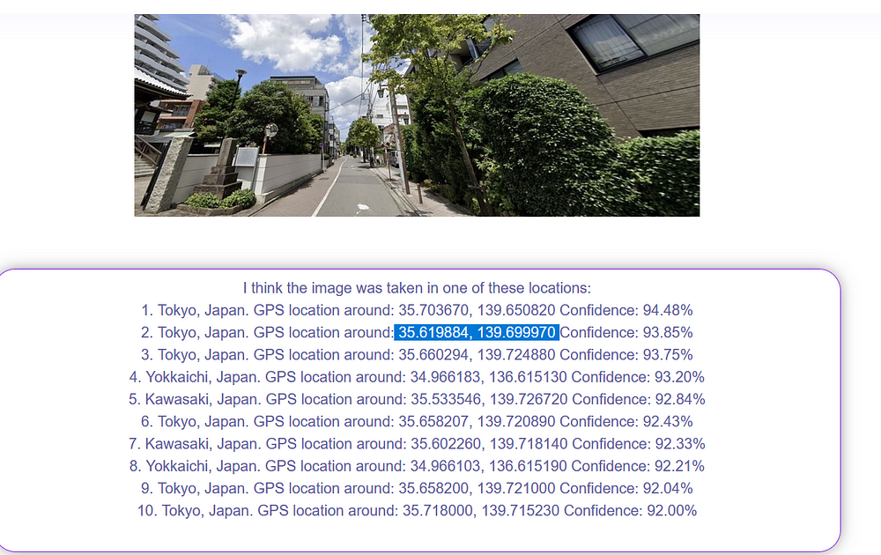since 1 decimal was asked so it was easier only 3 locations I had to check :)

The first location failed and I was thinking may be the AI is wrong. But I went for the second one, and it was correct!

**CHALLENGE 1.2**

On checking the file type and metadata by exiftool, there wasn’t much interesting information.

So, I went forth with strings command.

base64 it seems

Passing that string to online decoder:

I tried to submit the flag as it is: FSIT{6mW@h@Aq.??}

:( But it didn’t work. I replaced FSIT with FLAG and tried to submit again. No result.

Somehow, it seemed the word before ‘.’ looked like “Guwahati” so I went with my instinct, and I modified:

FSIT{6mW@h@Aq.??} => FLAG{6uW@h@Ti.??}

And it worked :?

**CHALLENGE 1.3**

I checked the file type first:

Nothing useful. On running, exiftool <file_name>, no useful data found.

Next, I tried to run strings <filename>. I found something intriguing: FLAG.wavRIFF

This made me think some files may be embedded in the image. On running, binwalk <filename>, I found this:

I extracted the file and played the Flag.wav file. It sounded like morse code. So I checked online: “Morse code decoder”

Using: <https://morsecode.world/international/decoder/audio-decoder-adaptive.html>

I got the flag as shown below:

flag: FLAG{DIBANG…IIT}

**CHALLENGE 2.1**

First went with checking the file type:

Since it’s an executable so I tried to run it:

It printed the same string in both yes and no. And when given different input, it resulted to invalid. No progress. So I went to check the strings, here I found something:

So, next, I loaded it up in IDA. In there, 3 functions were important to get the flag. After analyzing the functions, I wrote the python code for printing the flag:

yes! the flag!!!!

**CHALLENGE 2.3**

I first checked the file type, and then ran the program without any arguments: it said to ask the right question. After, that I checked the strings, there was print_flag() like in the prev case.

So, I launched it up in IDA. On checking the main function, it was calling the print_flag(). Also, it was checking if the argument provided is “./Wings_Of_Freedom”. I tried to give that as an input but it was not giving any result.

Then, I started the debugger. On checking the value after the argument was passed, it was not set as expected so I modified the register values at two points:

here rax had to be set 1 so that it jumps to loc_173B

After which, I got the flag:

flag :)